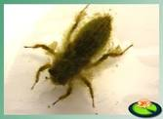[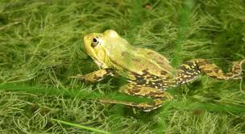](https://www.google.nl/imgres?imgurl=https://www.ivn.nl/sites/ivnn/files/styles/header_image_l/public/uploads/kikkertje_oo_0.jpg?itok%3DUppPG44-%26timestamp%3D1560347647&imgrefurl=https://www.ivn.nl/afdeling/zuid-kennemerland/activiteiten/op-zoek-naar-waterbeestjes&tbnid=aEJWOZ4nTQnsVM&vet=12ahUKEwjSquqiloPoAhWVt6QKHSW2BKkQMygwegQIARBu..i&docid=78j0y1x__4G5_M&w=1280&h=700&q=waterbeestjes&hl=nl&ved=2ahUKEwjSquqiloPoAhWVt6QKHSW2BKkQMygwegQIARBu)[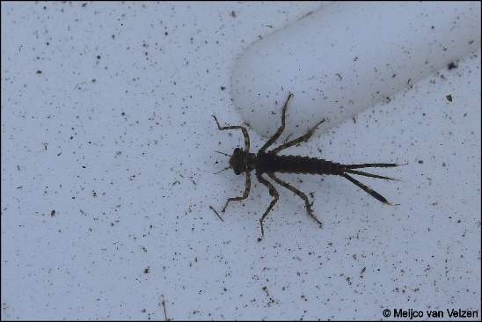](https://www.google.nl/url?sa=i&url=https://meijco.blogspot.com/2016/08/waterbeestjes.html&psig=AOvVaw0ky2SXA_o5KUC90wiGsjZS&ust=1583492201836000&source=images&cd=vfe&ved=0CAIQjRxqFwoTCLDfrKOWg-gCFQAAAAAdAAAAABAH)[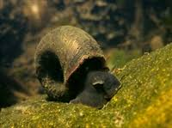](https://www.google.nl/imgres?imgurl=https://www.beeldschoonwater.nl/friksbeheer/wp-content/uploads/2013/12/Waterbeestjes-De-posthoornslak.jpg&imgrefurl=https://www.beeldschoonwater.nl/waterkaart/de-posthoornslak/&tbnid=7DCtCpWxthNjmM&vet=10CJ0BEDMo-gJqFwoTCLDfrKOWg-gCFQAAAAAdAAAAABAF..i&docid=Et6OYzAxvWcQ6M&w=200&h=149&itg=1&q=waterbeestjes&hl=nl&ved=0CJ0BEDMo-gJqFwoTCLDfrKOWg-gCFQAAAAAdAAAAABAF)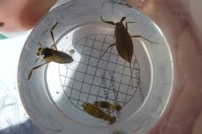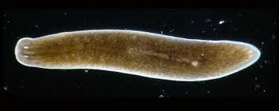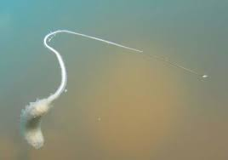[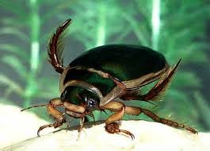](https://www.google.nl/imgres?imgurl=http://denhaneker.nl/wp-content/uploads/2017/10/G4.jpg&imgrefurl=https://denhaneker.nl/ecologisch-beheer-sloten-natte-dooradering/&tbnid=nnEyQPj2gtHXFM&vet=10CCMQMyh1ahcKEwjostuHmIPoAhUAAAAAHQAAAAAQAw..i&docid=oi7Hnwz8Z8cPiM&w=265&h=190&q=macrofauna%20water&hl=nl&ved=0CCMQMyh1ahcKEwjostuHmIPoAhUAAAAAHQAAAAAQAw)[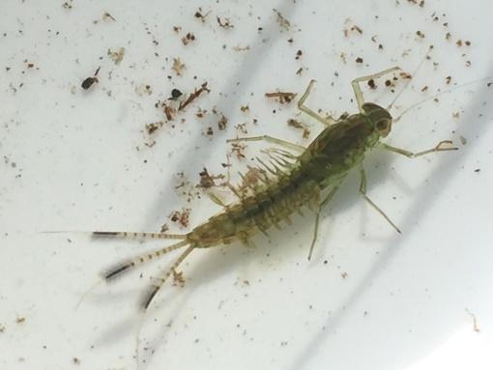](https://www.google.nl/url?sa=i&url=http://wandel-inge.weebly.com/excursies-ngo/slootjesexcursie-mozartvijver-eelde6219737&psig=AOvVaw3_8w_fOpb2Jk8TUSHaOhUx&ust=1583493026636000&source=images&cd=vfe&ved=0CAIQjRxqFwoTCKi2yqyZg-gCFQAAAAAdAAAAABAE)[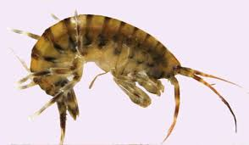](https://www.google.nl/imgres?imgurl=http://www.wew.nu/bw40/beeld/1402BrakFig7.jpg&imgrefurl=http://www.wew.nu/bw40/item.php?id%3D27&tbnid=7H9wysxdjyXezM&vet=10CEsQMyiJAWoXChMI6LLbh5iD6AIVAAAAAB0AAAAAEAM..i&docid=jvzTrUwipnG2AM&w=467&h=272&q=macrofauna%20water&hl=nl&ved=0CEsQMyiJAWoXChMI6LLbh5iD6AIVAAAAAB0AAAAAEAM)[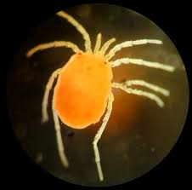](https://www.google.nl/imgres?imgurl=x-raw-image:///9d3c6a6ab6c1b4e29e02f8f23fcc4977502d219cc02dd865479abc51cc47edc9&imgrefurl=https://www.helpdeskwater.nl/publish/pages/132129/macrofaunanieuwsmail_126-_23_november_2015.pdf&tbnid=4rTBtmpqPJ109M&vet=10CFEQMyiMAWoXChMIgPvo25iD6AIVAAAAAB0AAAAAEAM..i&docid=kqjxWhO_DOZ9qM&w=748&h=737&q=macrofauna%20wateronderzoek&hl=nl&ved=0CFEQMyiMAWoXChMIgPvo25iD6AIVAAAAAB0AAAAAEAM)[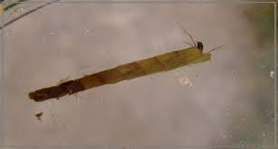](https://www.google.nl/imgres?imgurl=https://www.alipobiolog.nl/wplog/wp-content/uploads/2014/06/20140607_1059kokerjuffer_sloot_Elswout4.jpg&imgrefurl=https://www.alipobiolog.nl/wplog/katten-en-hond/tweede-waterexcursie/attachment/olympus-digital-camera-1918/&tbnid=TqcbBOaTYGnSWM&vet=12ahUKEwj1-5uQmYPoAhWiIMUKHTQVBx0QMygVegQIARAr..i&docid=d5-8trr3W-0rMM&w=1134&h=609&q=kokerjuffer&hl=nl&ved=2ahUKEwj1-5uQmYPoAhWiIMUKHTQVBx0QMygVegQIARAr)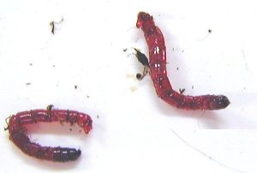[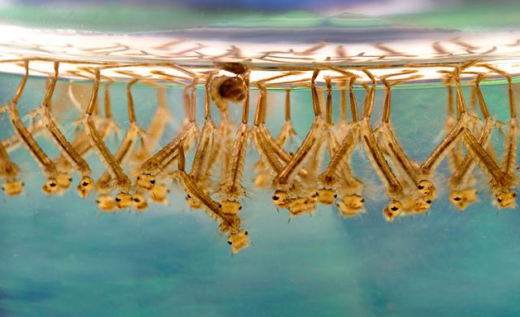](https://www.google.nl/url?sa=i&url=https://groot-rotterdam.nl/vliegvissen/87-entomologie&psig=AOvVaw3_8w_fOpb2Jk8TUSHaOhUx&ust=1583493026636000&source=images&cd=vfe&ved=0CAIQjRxqFwoTCKi2yqyZg-gCFQAAAAAdAAAAABAJ)[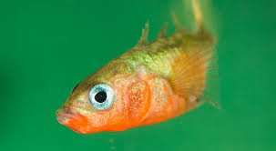](https://www.google.nl/imgres?imgurl=x-raw-image:///6c0645fb7cd7f90aa9944d39dfefea02a6afc18d1e200ba94db970abc8d79bb1&imgrefurl=http://www.doetsdesign.com/deltaindeklas/downloads/stekelbaars-reiziger-WERKBLAD.pdf&tbnid=CvnXfPtFBmwhrM&vet=10CJ0BEDMo-gJqFwoTCKi2yqyZg-gCFQAAAAAdAAAAABAQ..i&docid=C_VxyBfEO9dXLM&w=899&h=495&q=haftenlarve&hl=nl&ved=0CJ0BEDMo-gJqFwoTCKi2yqyZg-gCFQAAAAAdAAAAABAQ)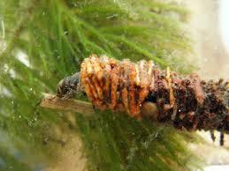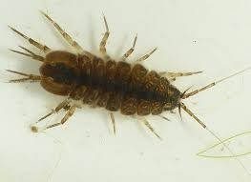

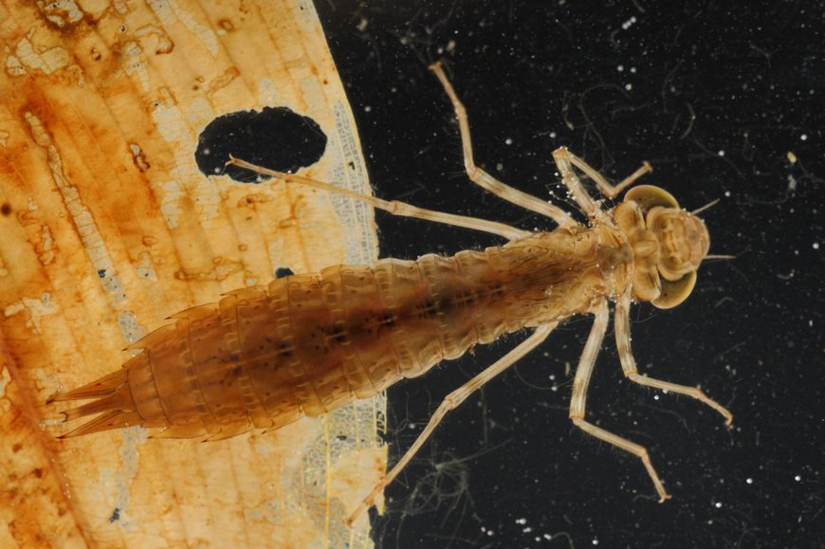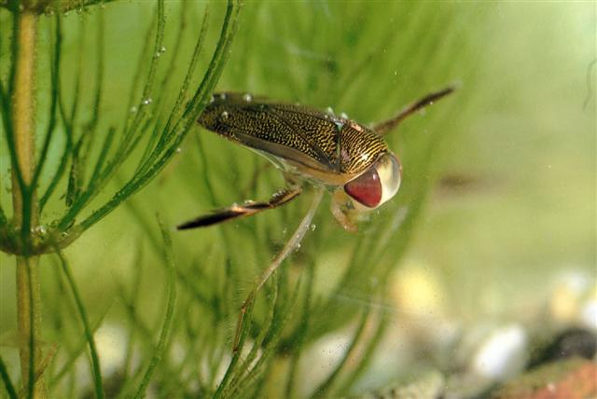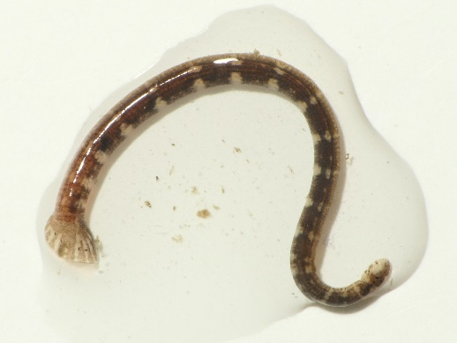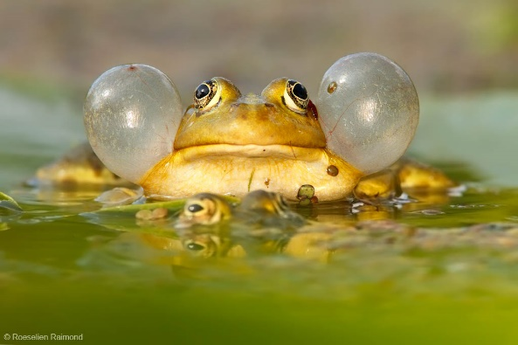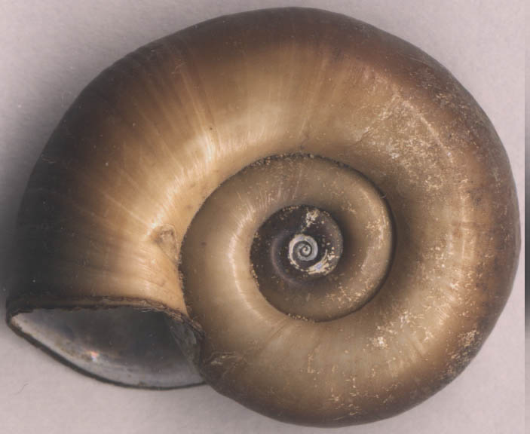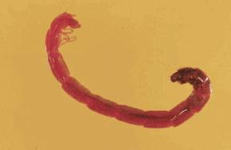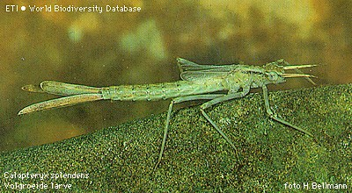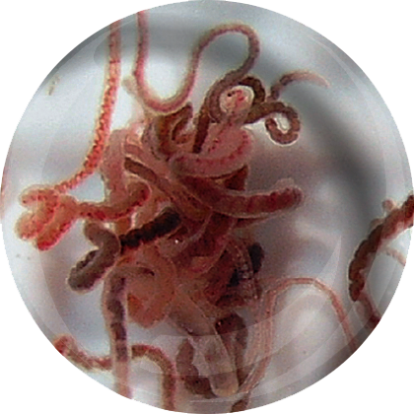

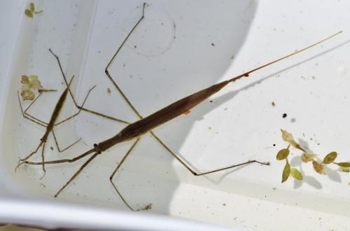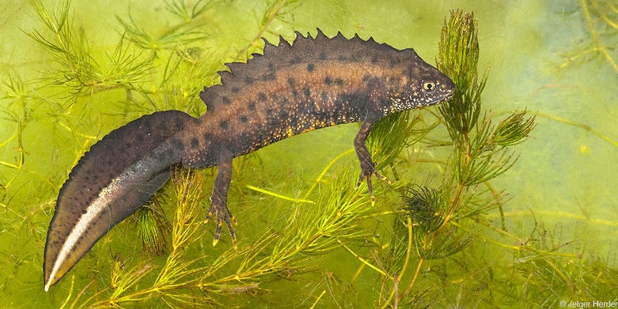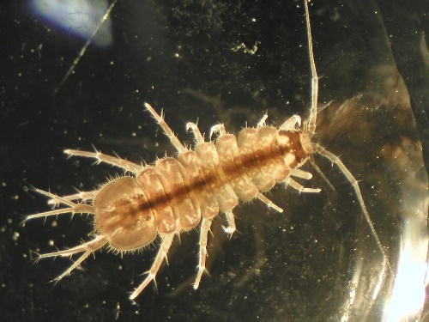[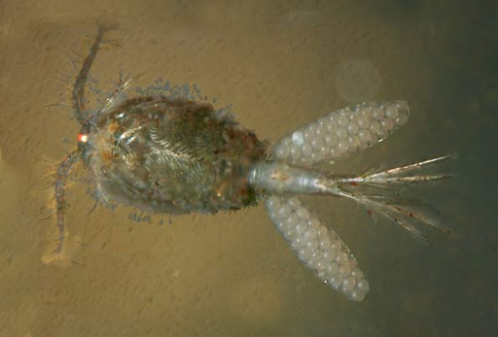](https://www.google.nl/url?sa=i&url=http%3A%2F%2Fwww.microcosmos.nl%2Fnvlooi%2Fcyclops01.htm&psig=AOvVaw2GywM6PpnG9BTNWgJBDGp7&ust=1584100741030000&source=images&cd=vfe&ved=0CAIQjRxqFwoTCNCSuqHxlOgCFQAAAAAdAAAAABAE)